**Electrical Safety in the Lab**

Hazards in clude shock and hazardous vapors

Sparks from malfunction equip can cause explosions. Ignite flamable liquids, vapors, and dust

Force carried by electrical current - volts

Most equipment 120 v

Special big equipment 240 volts

Current flow of electricity. Intensity measure in amperes.

Most wires in lab can safely hold 20 amps

Current, NOT voltage causes show

Just 6 100th of amp - christmas tree bulb is fatal if goes through heart

Flow of electricity can also be broken by fuse/circuit breaker

By equipment, in lab, or external

When overloaded, fuse will trip, disrupting electricity

Grounding

Stray electricity is always being pulled towards the ground.

Controlled grounding safe guards against this problem

Outlet must be connected to ground. Must test outlet.

To add safety ground fault circuit Interupter (GFCI) Senses stray electricity. If stray electricity, shuts of flow of current. Act quickly.

Circuit breaker/fuses can’t act quickly enough to protect you from shock but GFCI can

Safe work practices

3 most common electrical hazards: Fires shocks burns

Faulty wiring bad - check wires for defects

Dont overload circuits by plugging too much equipment in wire strips.

Try to not use extension cords. Eventually wear down

Dont use electrical tape to repair extension cords

Wires should be double insulated

Damaged connections can spark

Dont fix equipment yourself.

If need to get inside, disconnect all power sources and lock out/tag out

If flammable items present - have special switch and motor that dont spark

Dont bring home equipment or power tools from outside if flammable vapors around

Never touch person in contact with live wire. Cut off electricity . Call for medical personal. Often result in fires. Fire safety important. Fire extinguishers. Electrical fires should be put out with Type C extinguishers.

Cover electrical wounds with loose bandages

May need cpr or treatment for shock

**Flammables and Explosives in the Laboratory**

Flammable - substance that will catch fire and burn

Zyleene commonly used flammable substance. One will ignite one ont. One cooled with dry ice

Flash point, lowest temp when substance gives off vapor that will burn

Vapor that burns, not substance itself

Flammables and explosives dangerous

Flammables

Gasoline. Vapor ignite at temp up to -45 F. Even at flash point and spark, gasoline might not catch fire. Depends on limits of flammability and gas air ratio

Lower flammable limit. Min percentage of vapor air for ignition to take place

Upper: above point where ignition can no longer happen

Diethyl Ether Lower 1.9%. Upper 36.5%

Volume of air. Will ignite if atmosphere between 1.9 and 36

IF enough vapor in air, atmosphere usually above toxic limits as well. All flammables also have ignition temperature - min temp required to cause self contained combustion regardless of the heat source involved.

Carbon disulfide 80C. Easily ignite nearby lightbulb

Remove heat or sparks equipment

Never use open flame or hot plate. Use heating mantel or hot bath

Static electric another thing to be concerned about. Use static guard devices

Gas Cylinders and Explosives

Strap or chain gas cylinders to bench or wall racks

Fittings and hoses checked regularly

Dont store gasses that could react next to each other

Maike sure labeling is correct

Color code not enough

Check for connections and leaks when take out of storage -> bubbles

Explosives

Temperature increases, light, mechanical shock and catalyst can cause reactions

Impurities can be unstable and dangerous

combinin g substances can cause explosion

Ventilation and storage

Must have enough ventilation to keep below lower flammable limit

Flashback - accidental reverse flow of flame back into container

Auxiliary ventilation sometimes required.

Carry in secondary containers

Cross any uneven surfaces carry carts with large wheels that can’t tip over

Every chemical have storage space returned to after each use.

Flammable liquid in red containers with yellow tape. Special containers

Label containers

Dont store on bench top. Not protected from fire

Dont store in fume hood

Flammables exceeding 1 liter in volume should be stored in a flammable proof cabinet (yellow). Dont have to be vented.Cabinet doors should bbe closed and locked

Never store in refrigerator unless certified explosion proof.

Storage levels of flammables and explosives. Cant store too much depending on facility

Safe work practices

Use smallest amounts possible for desired reaction. Put behind flash shield if change of explosion. Wear special glasses and coat

Disposing of waste can be tricky. Consult datasheets. Very few can go down drains.

Flammavbles should always be diluted when poured down drain. May be able to recycle, depending. Never wash explosive residues down drain or recycle.

Waste containers properly labeled and stored.

Federal and local disposal regulations

Spills and evacuations

All ignition sources turned off.

Activating carbon absorbants

Always think about what to do in emergency

Fundamentials of Laser Safety

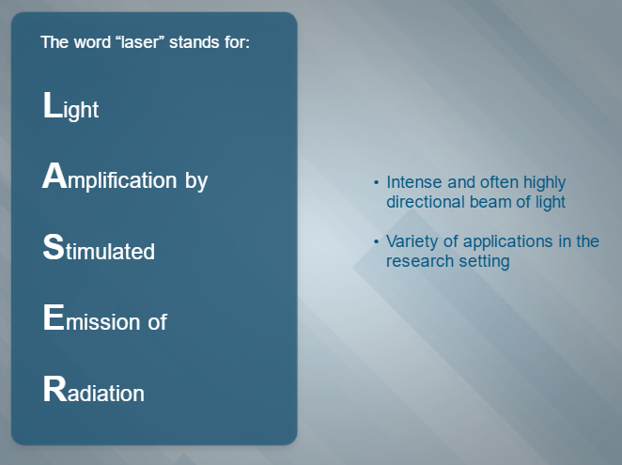

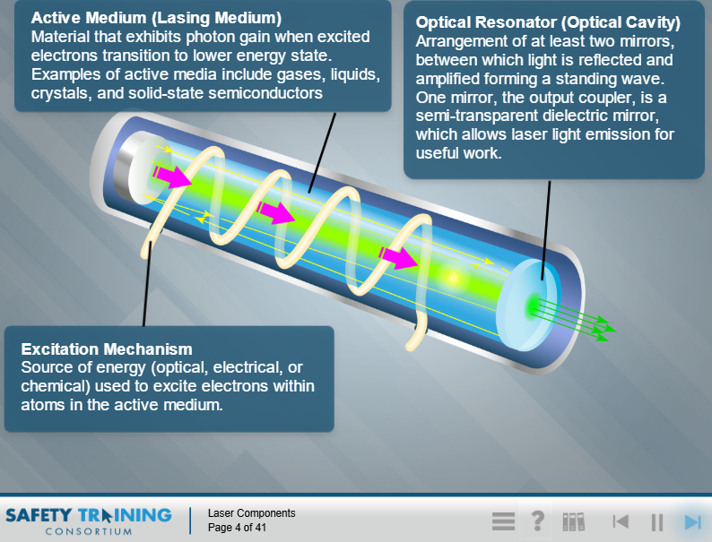

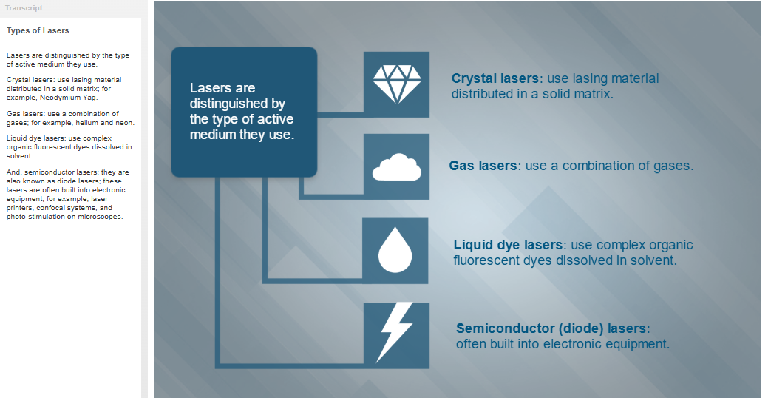

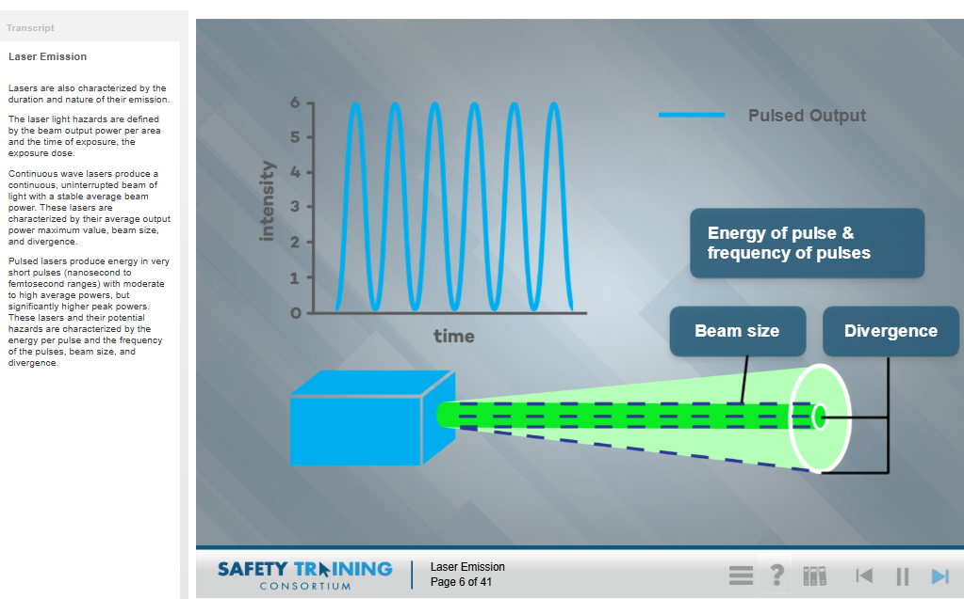

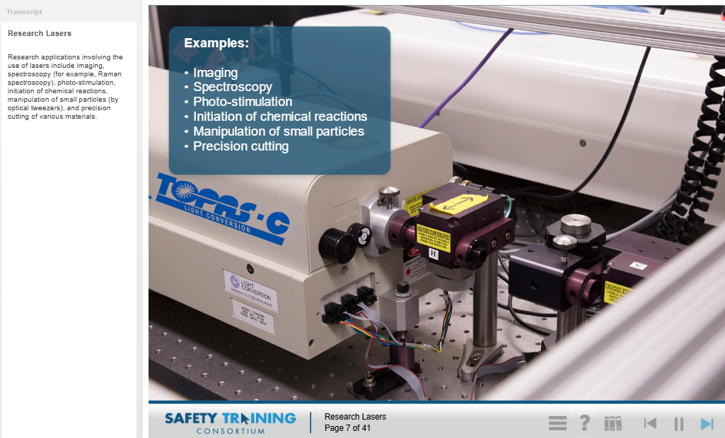

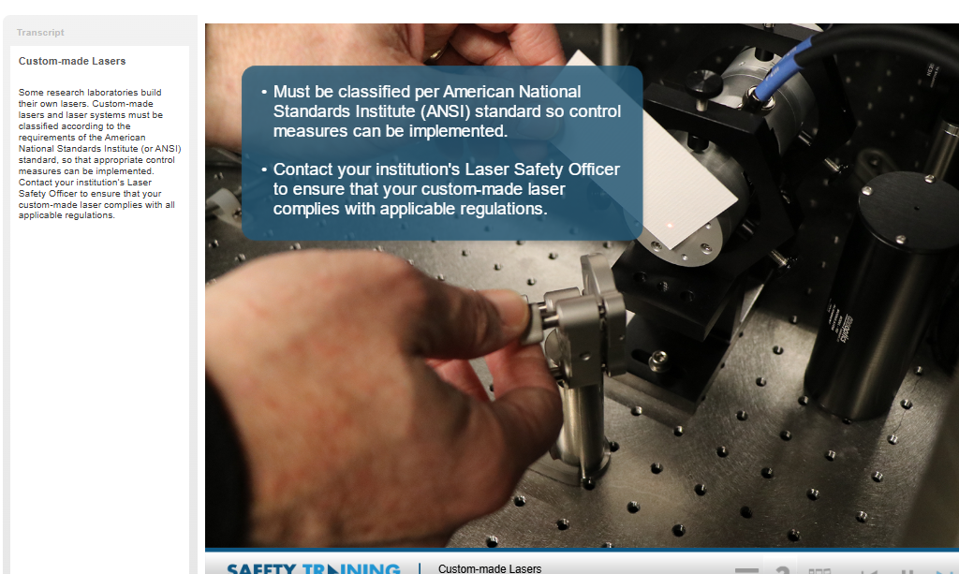

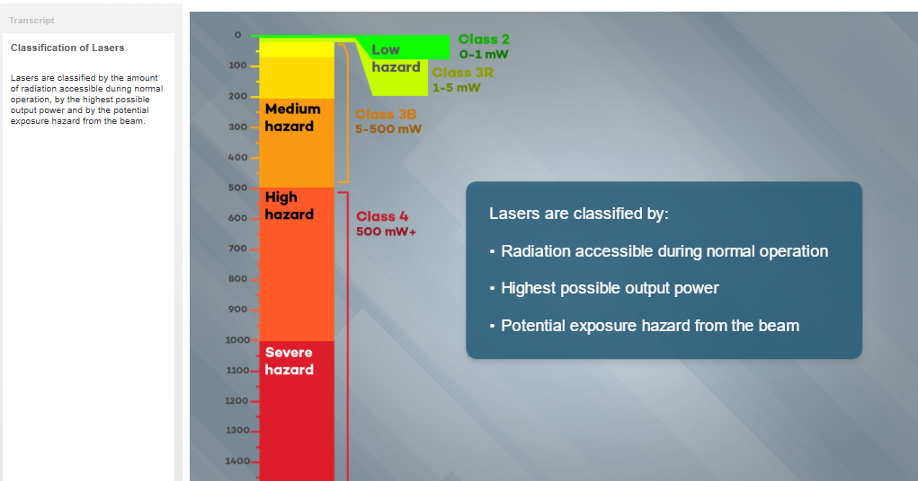

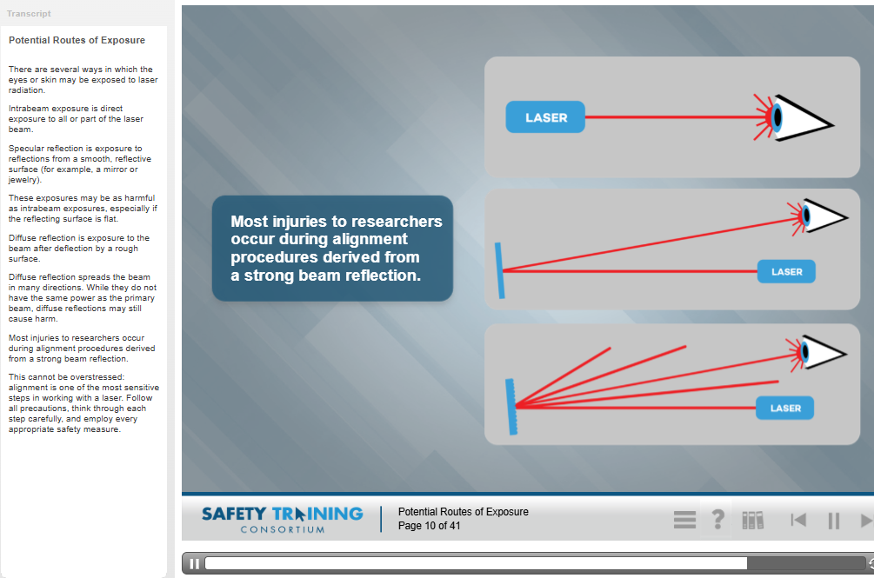

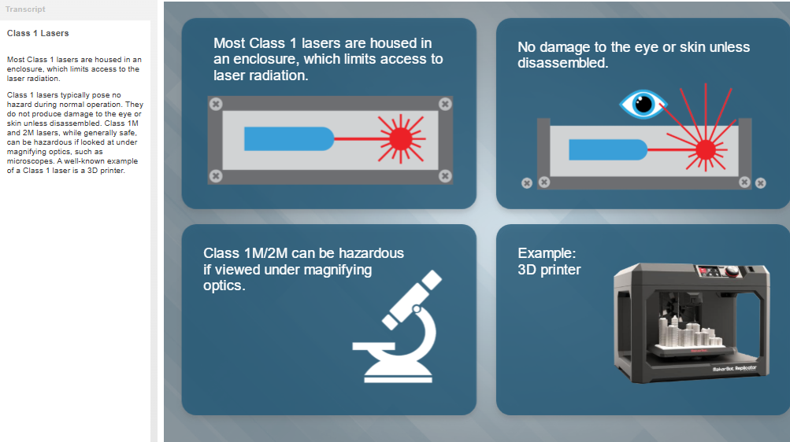

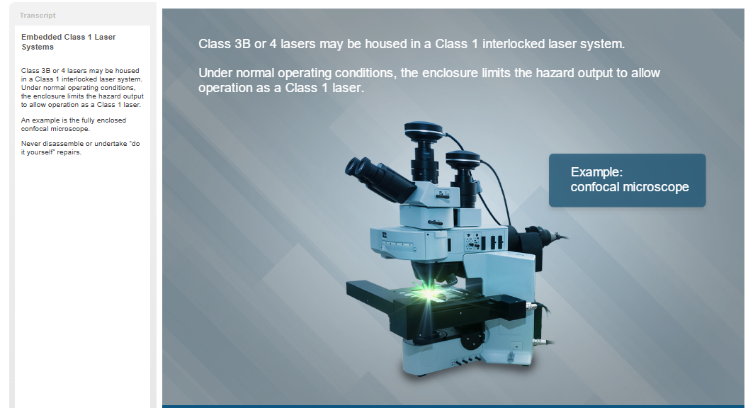

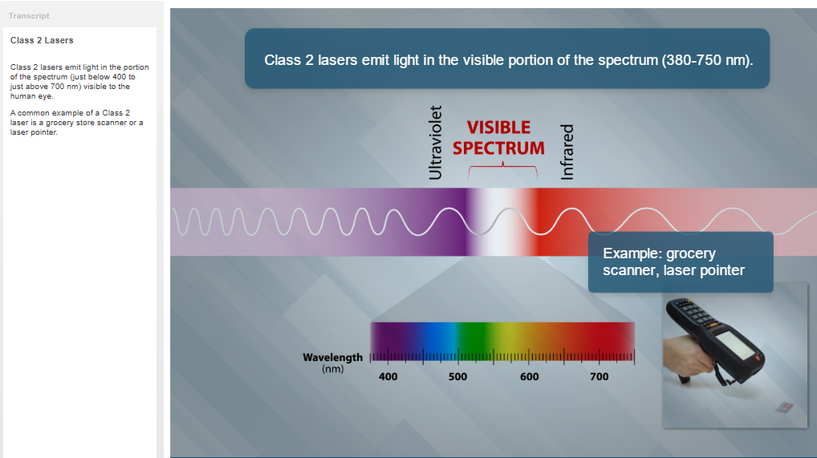

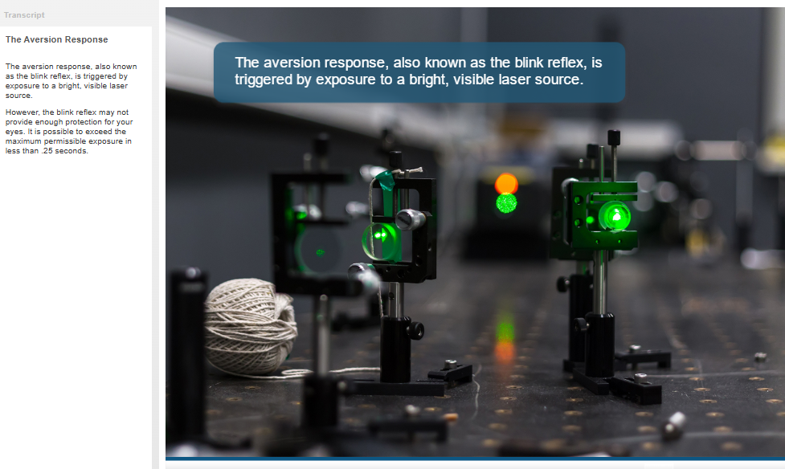

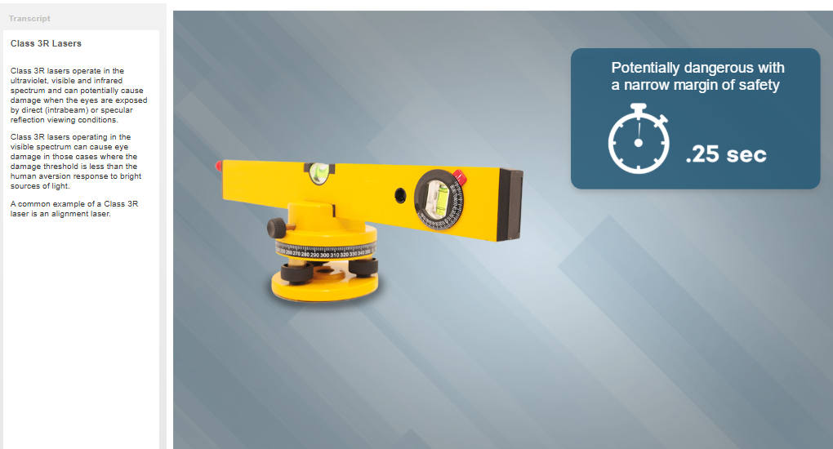

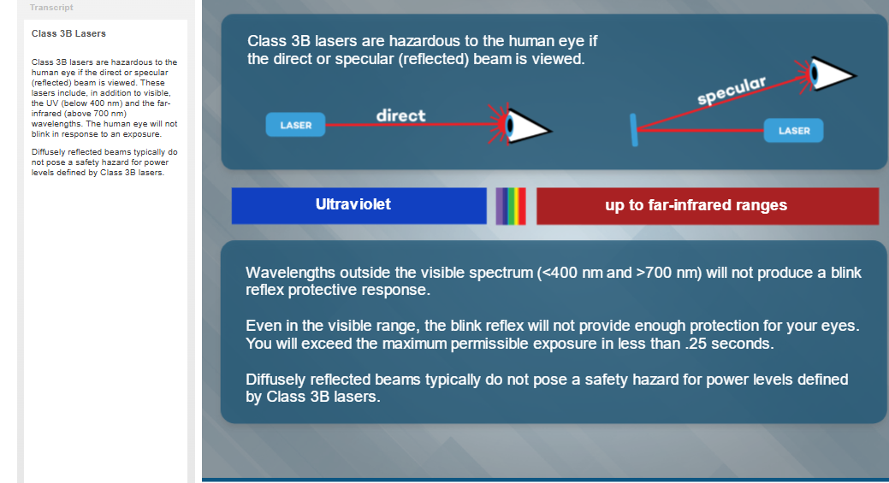

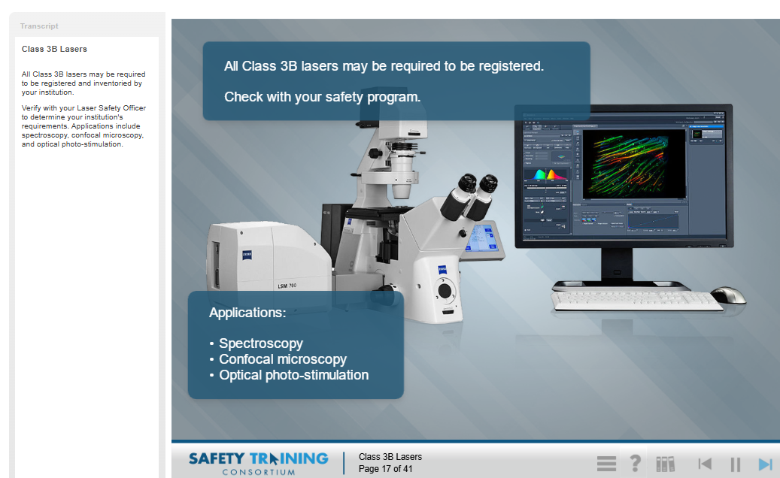

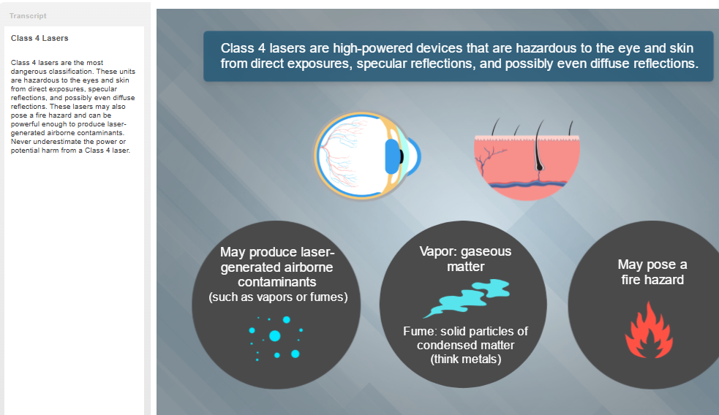

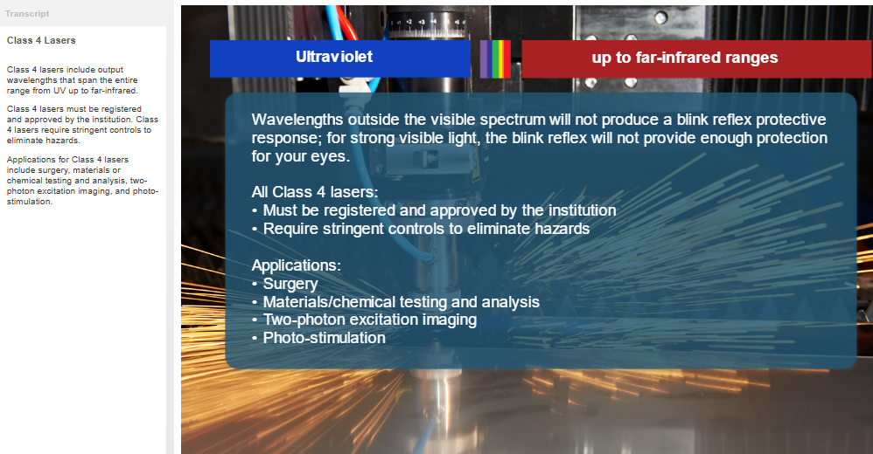

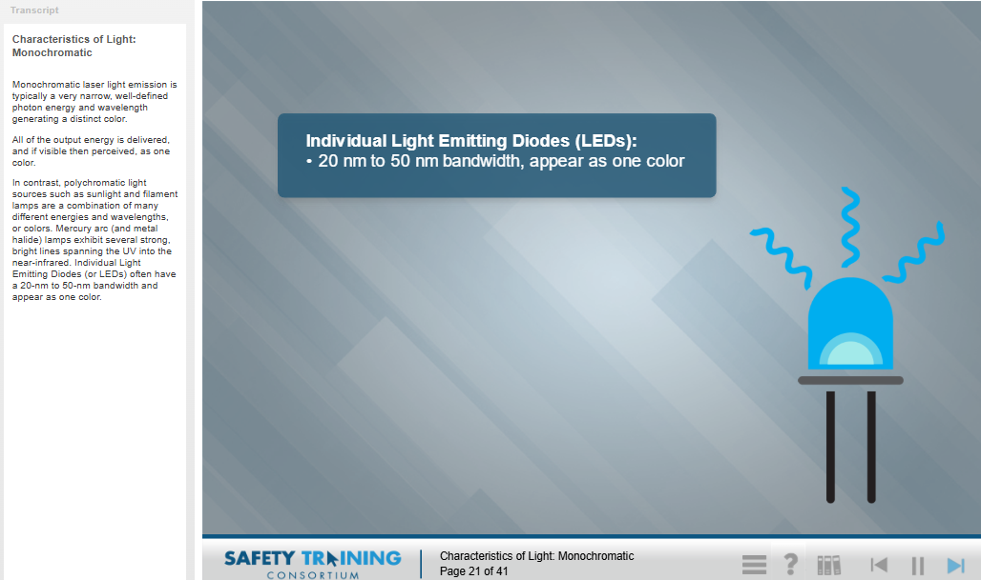

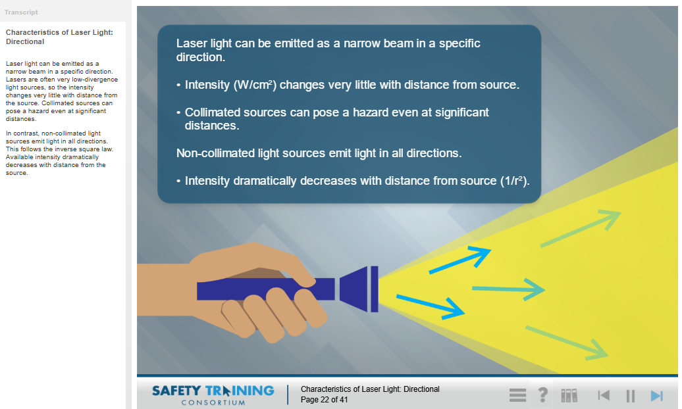

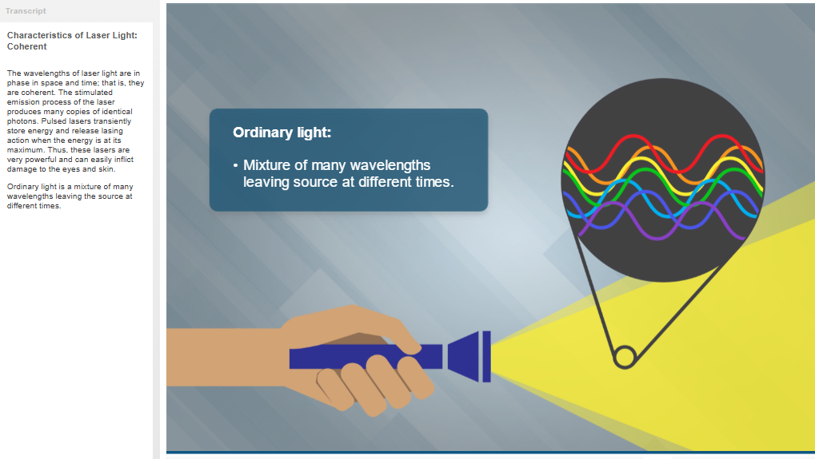

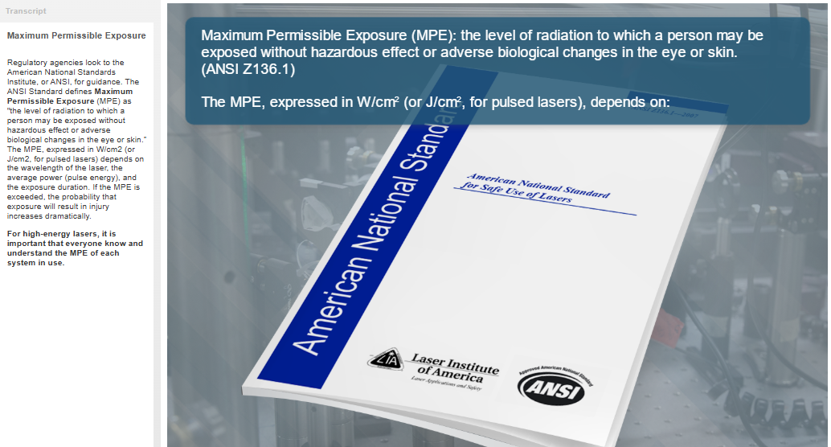

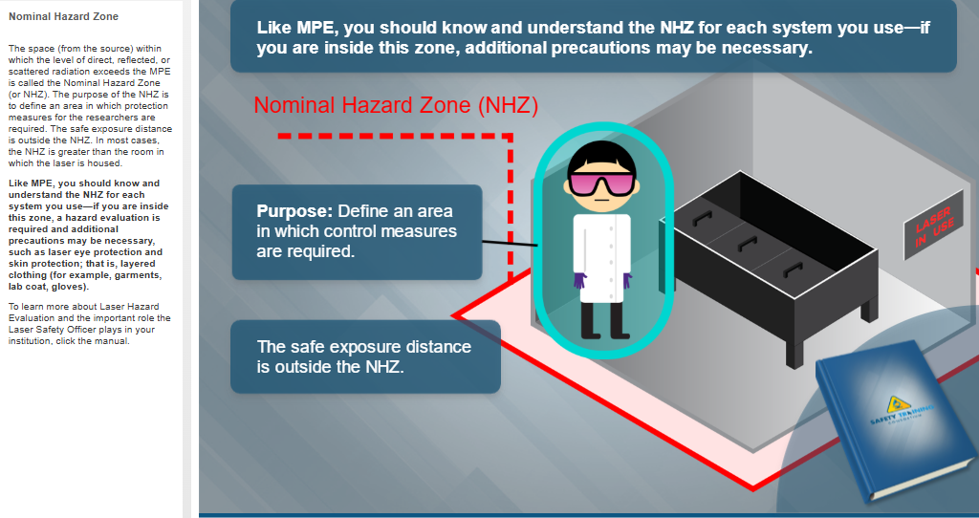

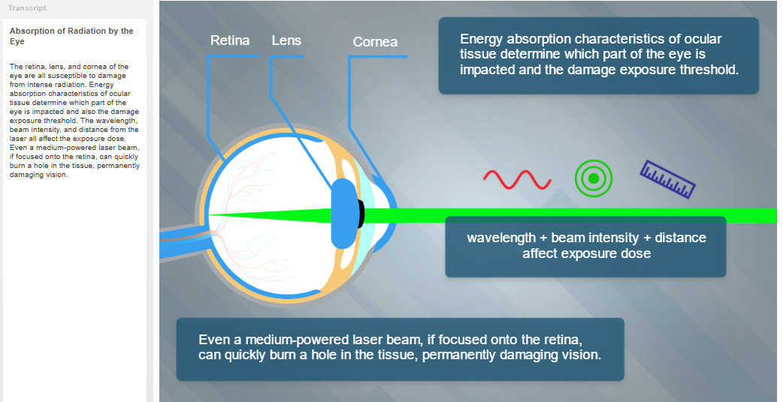

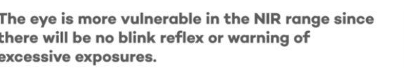

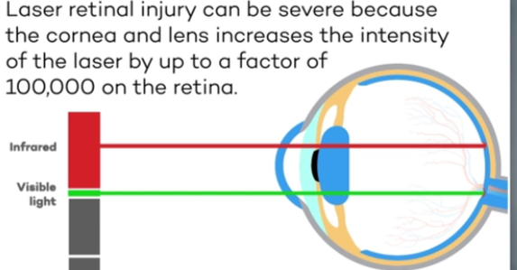

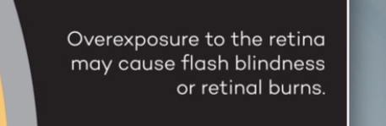

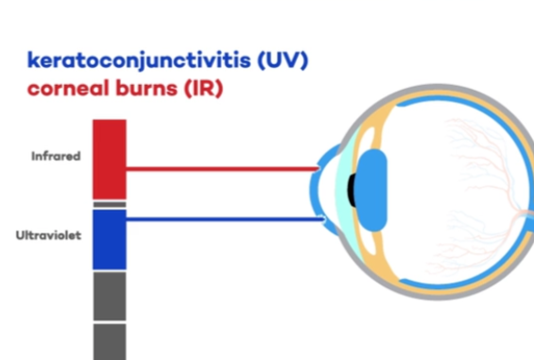

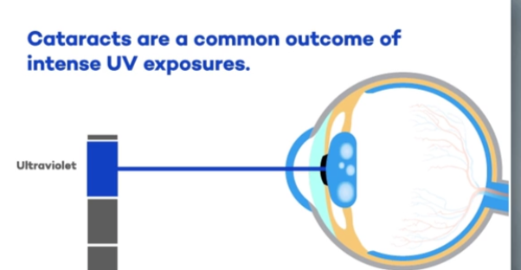

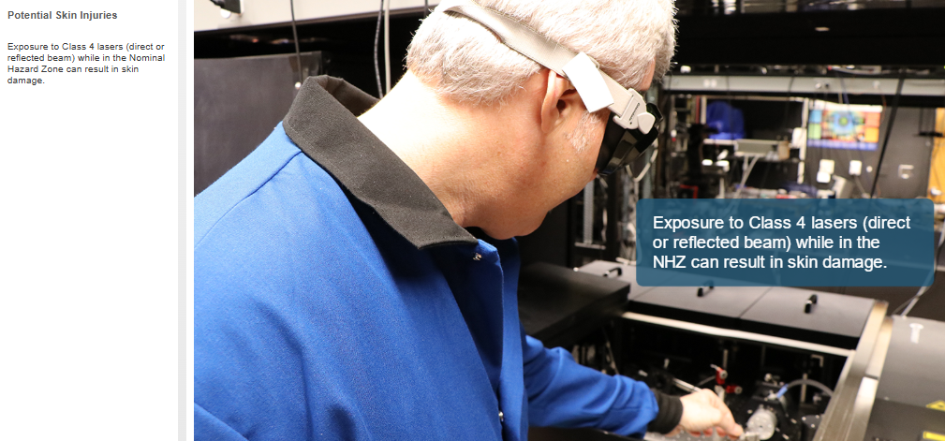

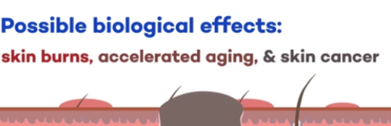

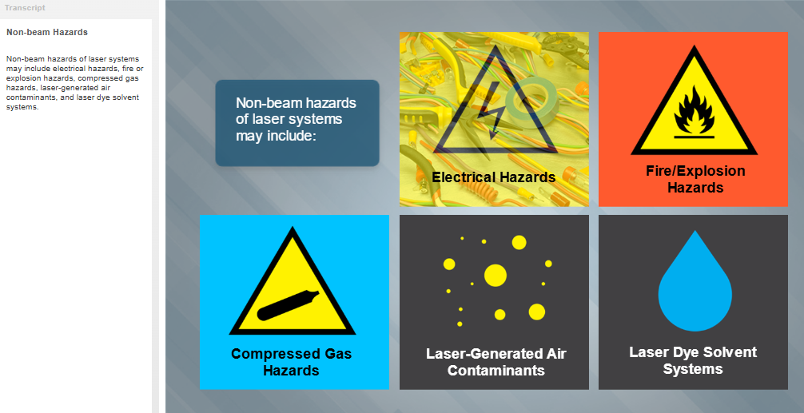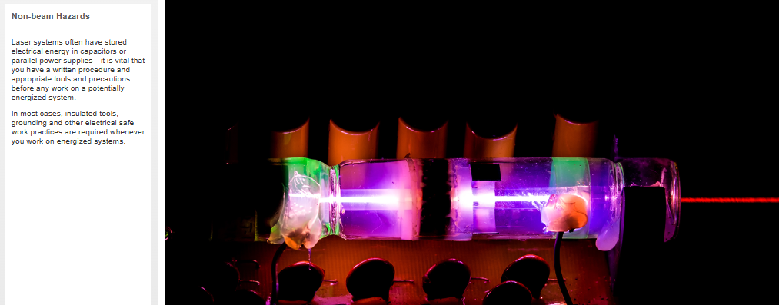

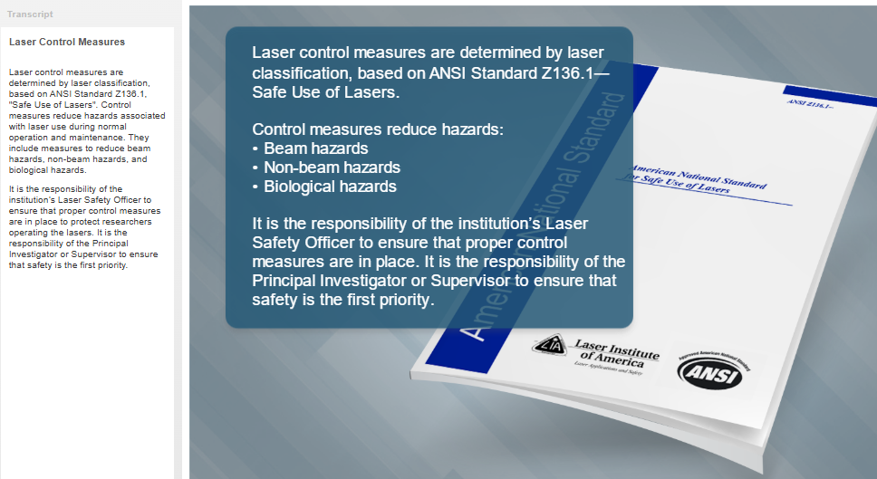

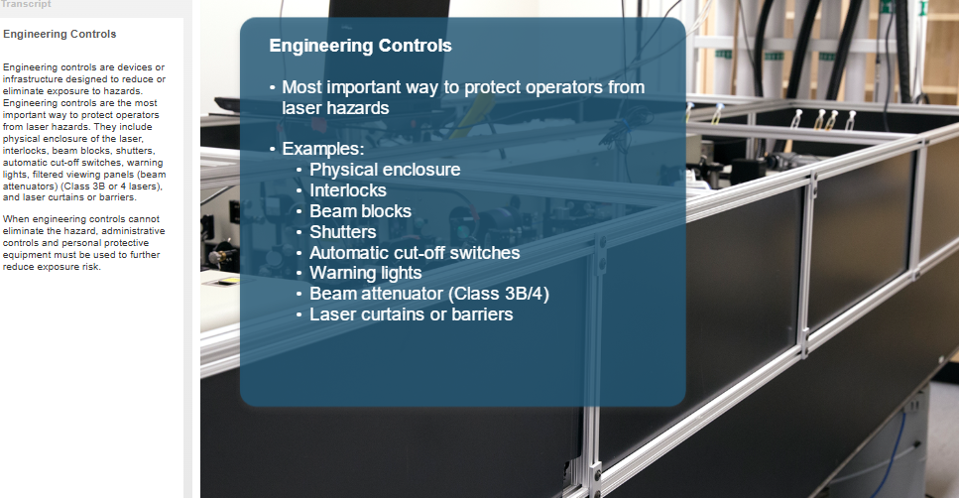

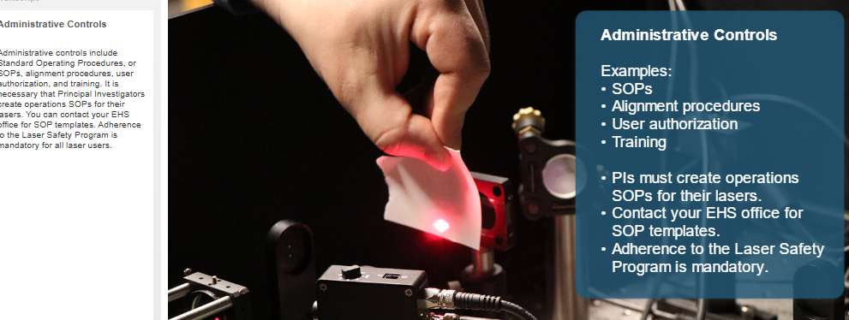

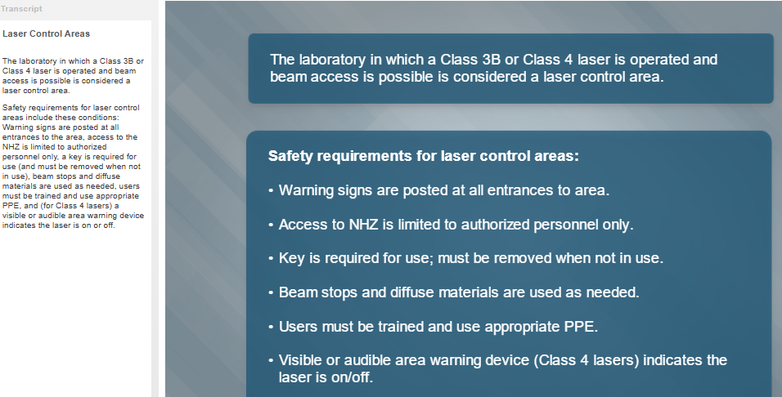

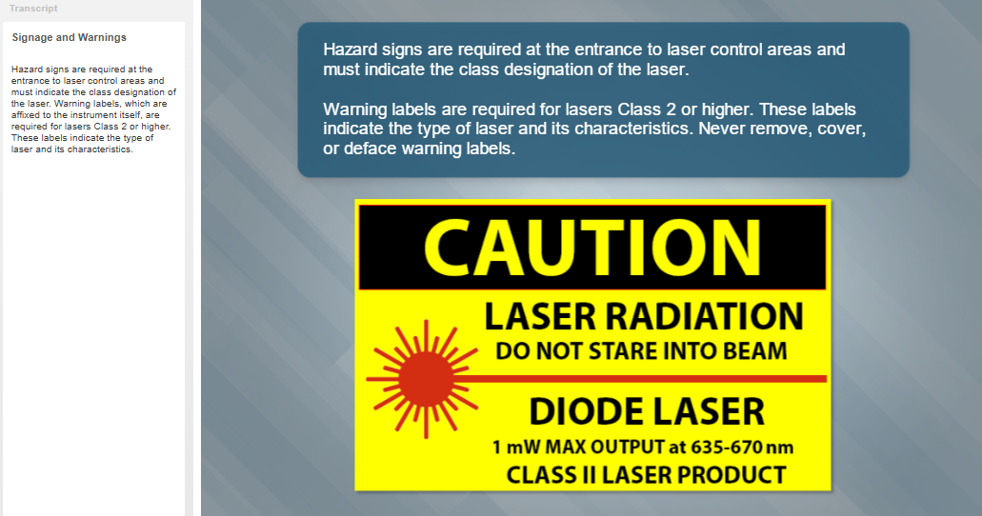

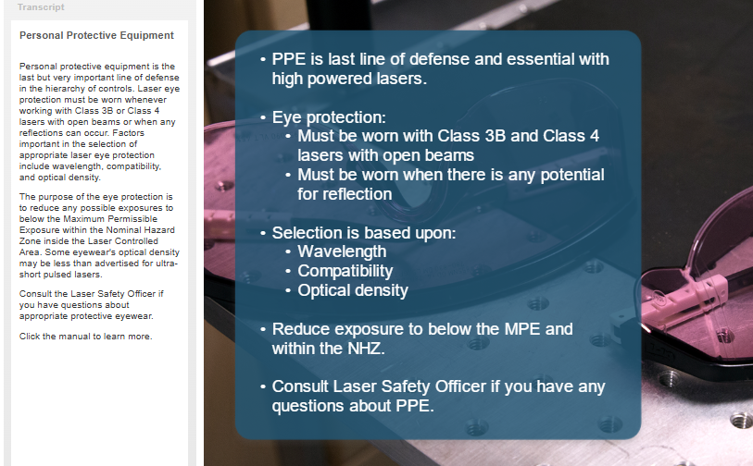

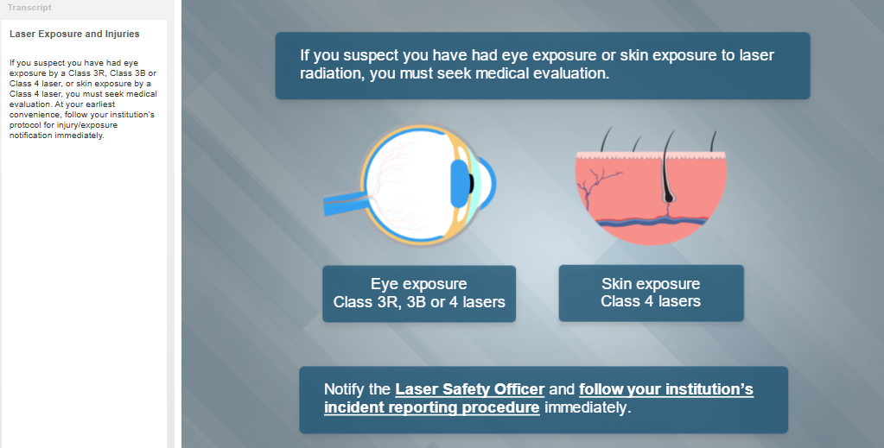

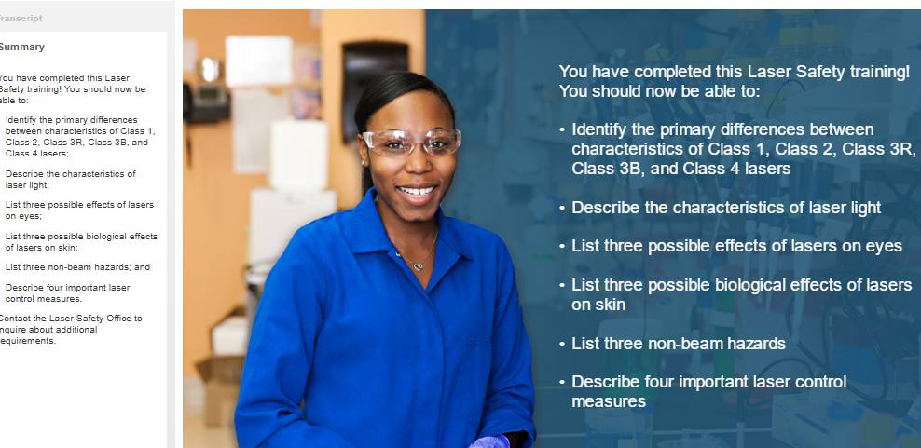

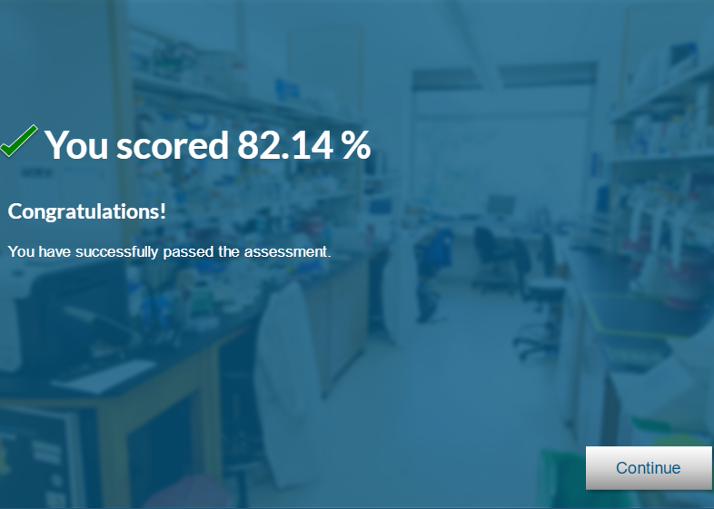

**Handling Compressed Gas**

* 4 ways to store compressed gas
  + Standard compression - remains in gas form
  + Liquid - for liquids that compress under ordinary temperatures or pressures ex CO 2 and propane
  + Dissolve a gas in solvent - such as acetylene
  + Compress to cryogenic liquid. Ex nitrogen oxygen and argon
* Cryogenics. Goggles face shield and insulated gloves. Wear safety shoes too.
  + Produce huge volumes of gas when vaporize
* If cylinder falls can turn into a rocket
* Storage
  + Cool dry well ventilated. Upright strapped into place
  + Out of direct sunlight
  + 20 feet between gasses that may interact
  + Never tamper with identifying labels. Cant rely on teh color
  + Know shelf live. Corrosive gases cant be more than 6. Ethylene gas no more than 3 months
* Handling
  + Never drag or roll the cylinder. Always use hand truck. Use cylinders. Let the cylinder go in elevator on its own. Use safety cap when traveling.
  + Dont try to catch falling cylinder
  + Wear safety shoes
  + Clamp next to stations
  + Chains must be as tight as possible
  + Never force cap off
* Regulators and relief devices
  + Regulator reduces gas pressure to safe
  + CGA? Washer
  + Never force a cga onto valve
  + Pressure relief device - opens to allow controlled release of gas
    - None on toxic or poisonous
* Dealing with leaks and emergencies
  + Use diluted soap bubble test.
  + If leak alert people, evacuate, notify supervisors

**Laboratory Hoods**

* Chemical exhaust hoods
  + Also protects from splashes and minor explosions
* Wear PPE even when hood
* Testing Laboratory Hoods
  + Checked when change in ventilation and regularly after
  + Measure flow of air 6 inches
  + Drafts greater than 20 fpm issues
  + Face velocity measured.
  + Should never be below 60 fpm
  + Face velocity should usuall be 80-100
  + High velocity can cause turbulence. Boo
  + Should not exceed 150 fpm
  + Observe smoke patterns to see if theres turbulence
* Using Laboratory Hoods
  + Work 6 inches inside hood
  + Elevate shakers
  + Never use as storage space
  + Keep sash closed as much as possible
  + Dont put solid objects such as paper
  + Never place your head inside
* Specialized lab hood
  + Biohazar caught biohazard particles
  + Dont evacuate into outside air
  + HEPA filter catches .3 micron at 99.99%. Particle not gas filter.
  + Perchloric acid hood. Never use with organics.
  + Radioisotpe hood
* Emergency Prep
  + Things can still spill.
  + Uncontrollable fire, close sash, leave

Orientation to Laboratory Safety

* Safety Data Sheets - SDS

**Planning for Lab Emergencies**

* Fire
  + Remove people out of harms wau
  + Do first aid
  + Assess equipment if can fight fire safely
  + Total evacuations
* If fire drop or fire blanket
* Turn off all heating devices and stop all reactions in process
* Chemical Spills
  + Location of release, quantity, properties, hazardous qualities, ppe
  + Spill control kits
  + Notify everyone, evacuate, mark doors when leave. Lockdown vents.
  + Determine if need respirator for spill area
  + Activated carbons keep something out of air
  + All areas involved in spill should be contaminated
* Safety Showers and Eyewashes

**Preventing Contamination in teh laboratory**

* Know about materials. sSafety data sheets
* Inhalation eye contact skin contact ingestion
* Use PPE engineering controls and safe work practices
* Monitor condition of PPE
* Change gloves once every 2 hours or when wet
* Engineering controls
  + Splash shields, fume hoods,
* Safe Work Practices
  + Good housekeeping, neat and orderly, small containers, put back where belongs, proper disposal, clean equipment decontaminate before leave,
  + Plan for disposal before starr procedure
  + Leave all stuff in lab before leave
  + Never leave lab with PPE
  + Dont take lab notebook to lunch
  + Dont rub your face

**Laser Safety**

* Continuous wave laser - provides light for period of time greater than or equal to 0.25 s
* Pulse laser, opposite, less than 0.25

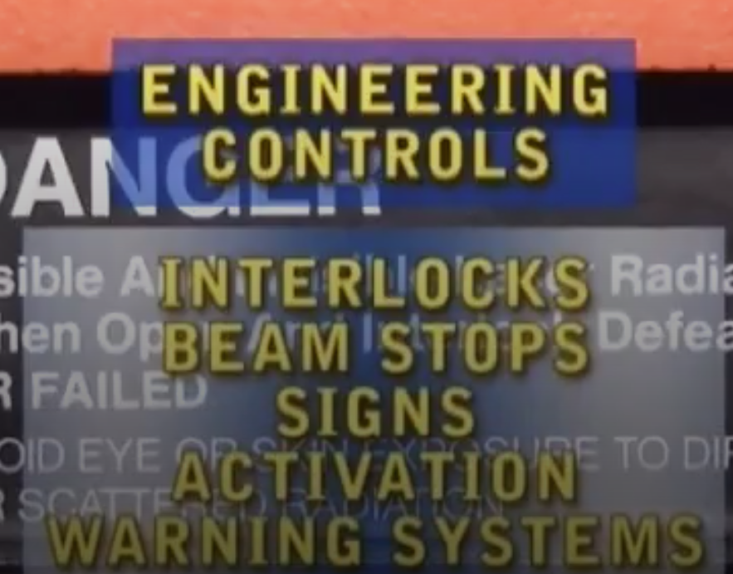

COE EH&S

<https://isupport.sjsu.edu/engineering/Dashboard>